**COVID-19 Analysis In INDIA**

**1. Introduction**

The Covid-19 pandemic has had a significant impact globally, and India has been no exception. This report presents an analysis of Covid-19 data in India, leveraging Tableau for visualization. The objective is to gain insights into the spread of the virus, vaccination progress, Death rate & Vaccination name.

### 2. Methodology

For this analysis, data was collected from Kaggle source.

.The data underwent preprocessing to clean and prepare it for analysis in Tableau.

Various visualization techniques were employed to explore and present the findings effectively.

**3. Requirement Analysis**

The analysis aimed to fulfill several objectives:

* Understand the geographic distribution of Covid-19 cases and deaths across different states in India.
* Explore demographic patterns by age group and gender.
* Track the trend of Covid-19 cases over time.
* Assess the progress of vaccination efforts, including the administration of first and second doses and the distribution of vaccines by type.
* Investigate the availability of testing labs across states for Covid-19 diagnosis.

### 4. Other Parameters depending upon the Projects

In addition to the primary objectives, the analysis considered other parameters such as population density, healthcare infrastructure, and government interventions to provide a comprehensive understanding of the Covid-19 situation in India.

### 5. All Visualizations

#### **Map: Total Death by State**

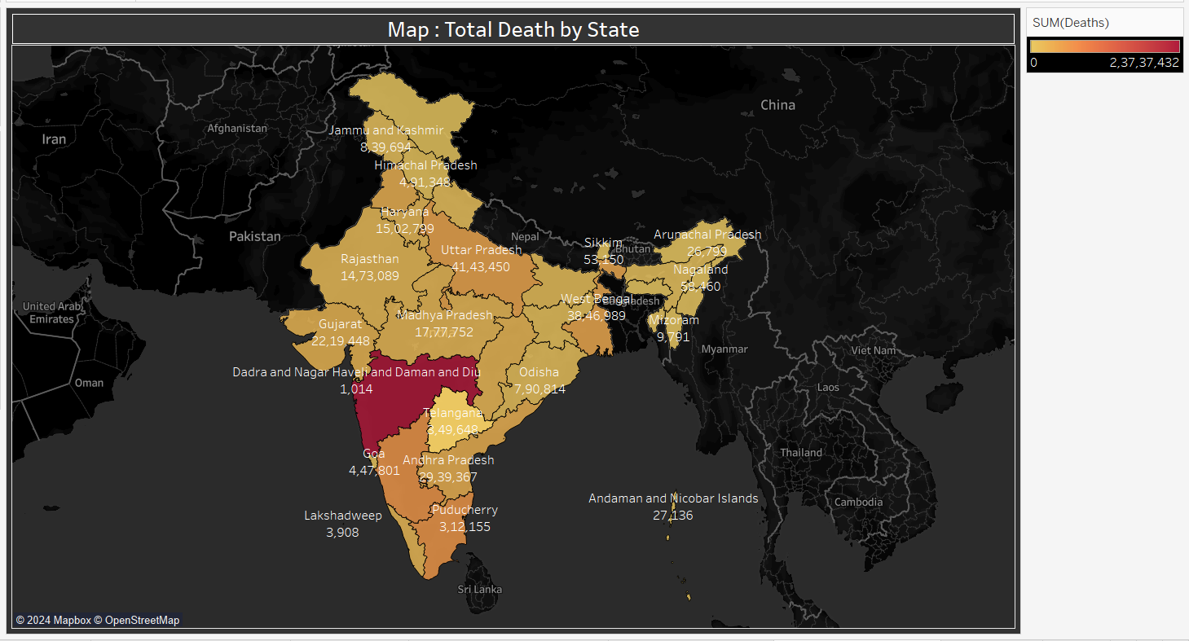

The map illustrates the total number of deaths attributed to Covid-19 in each state. This visualization helps identify regions with higher mortality rates.

#### **Age Group Details**

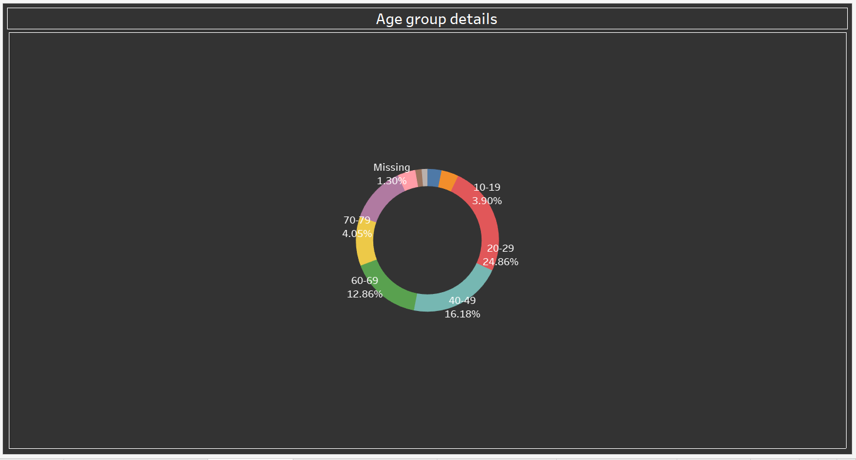

The donut chart provides a breakdown of Covid-19 cases by age group, allowing for the examination of age-related patterns in infection rates.

#### **Covid Cases by State**

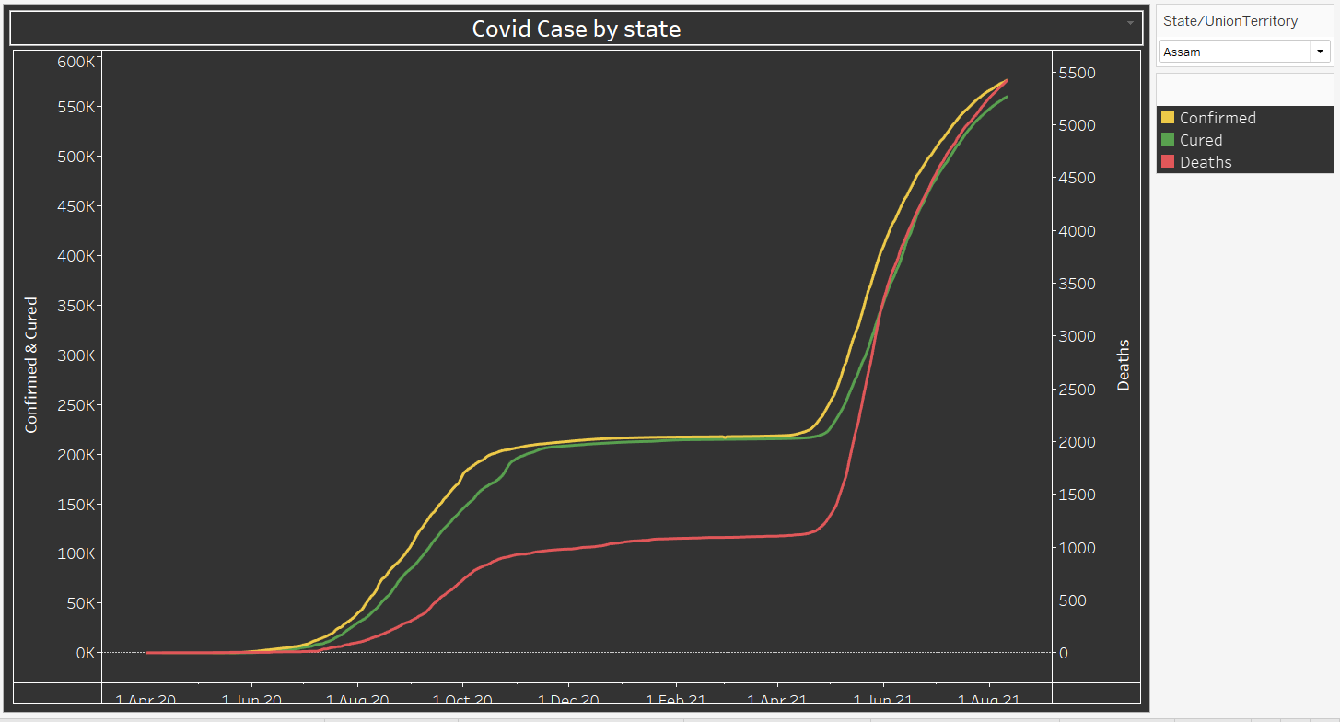

The line chart depicts the trend of Covid-19 cases over each state & tracking of confirmed cases, no. of cured & no. of death.

#### **First vs. Second Dose Administered**

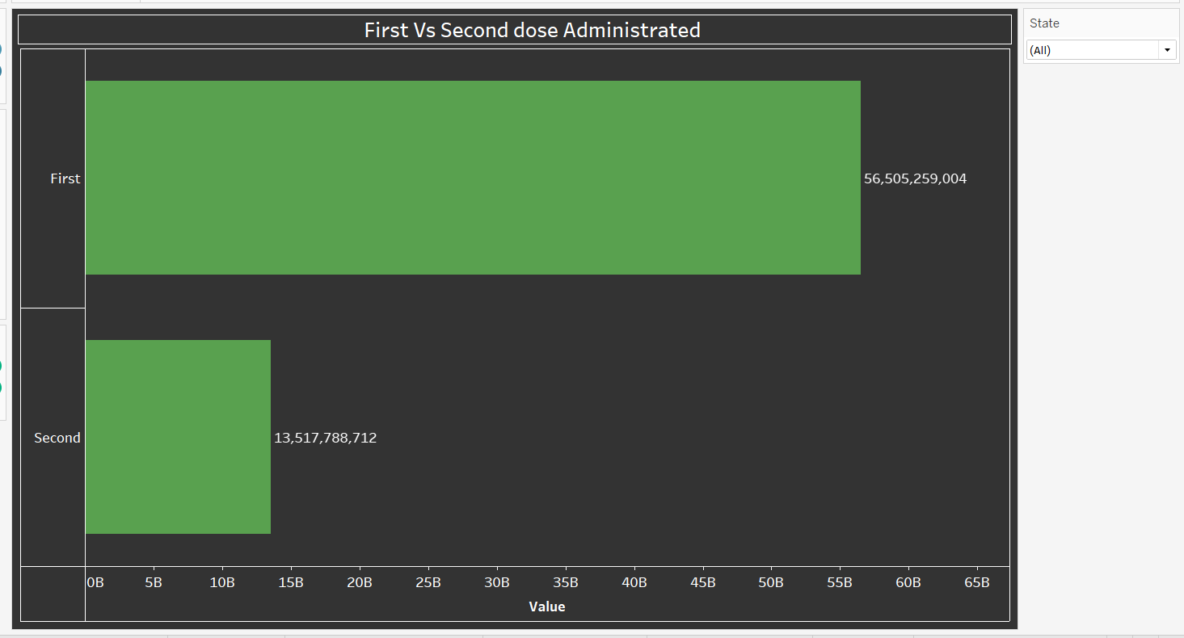

The horizontal bar chart compares the administration of the first and second doses of vaccinesin each state, highlighting the progress of vaccination campaigns.

#### **Dose Administered by Vaccine**

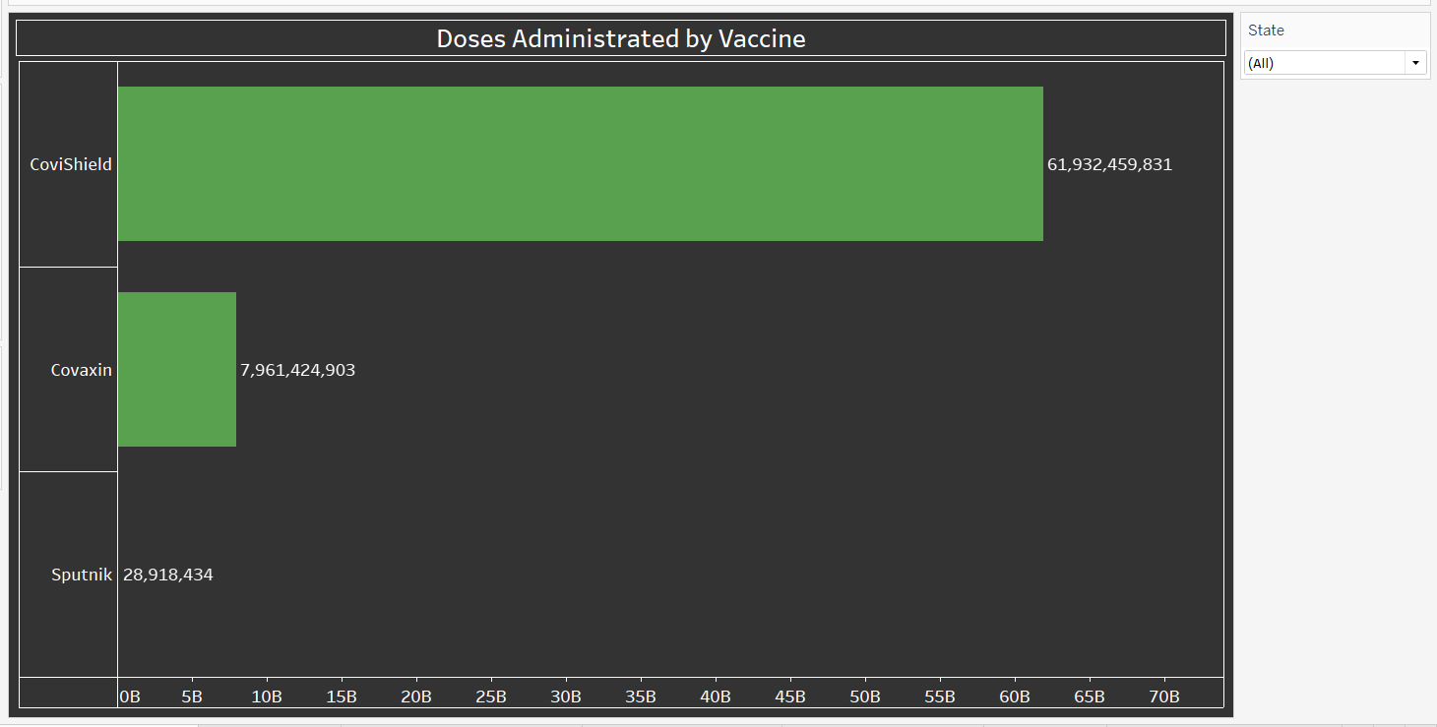

This horizontal bar chart displays the distribution of vaccine doses administered by type, offering insights into the usage of different vaccines.

#### **Gender without missing values**

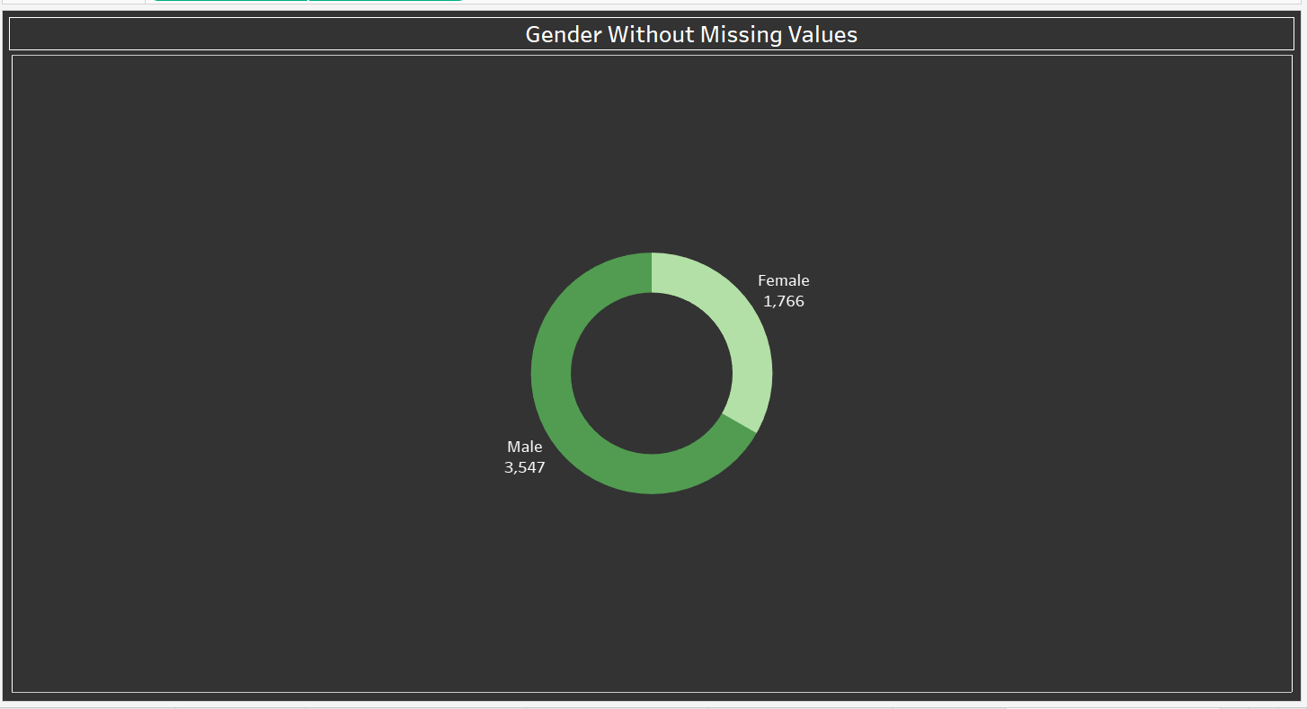

The donut chart illustrates the gender distribution of Covid-19 cases, helping identify any gender-specific disparities in infection rates.

#### **ICMR Testing Labs in each State**

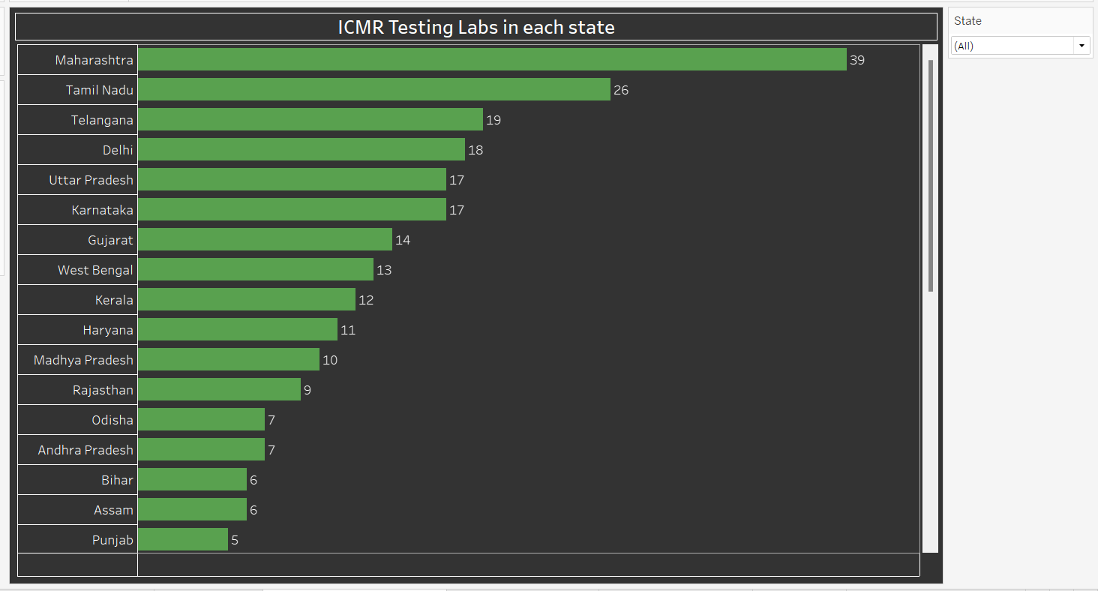

This horizontal bar chart shows the number of ICMR testing labs available in each state, indicating the testing capacity and infrastructure across regions.

#### **Dashboard**

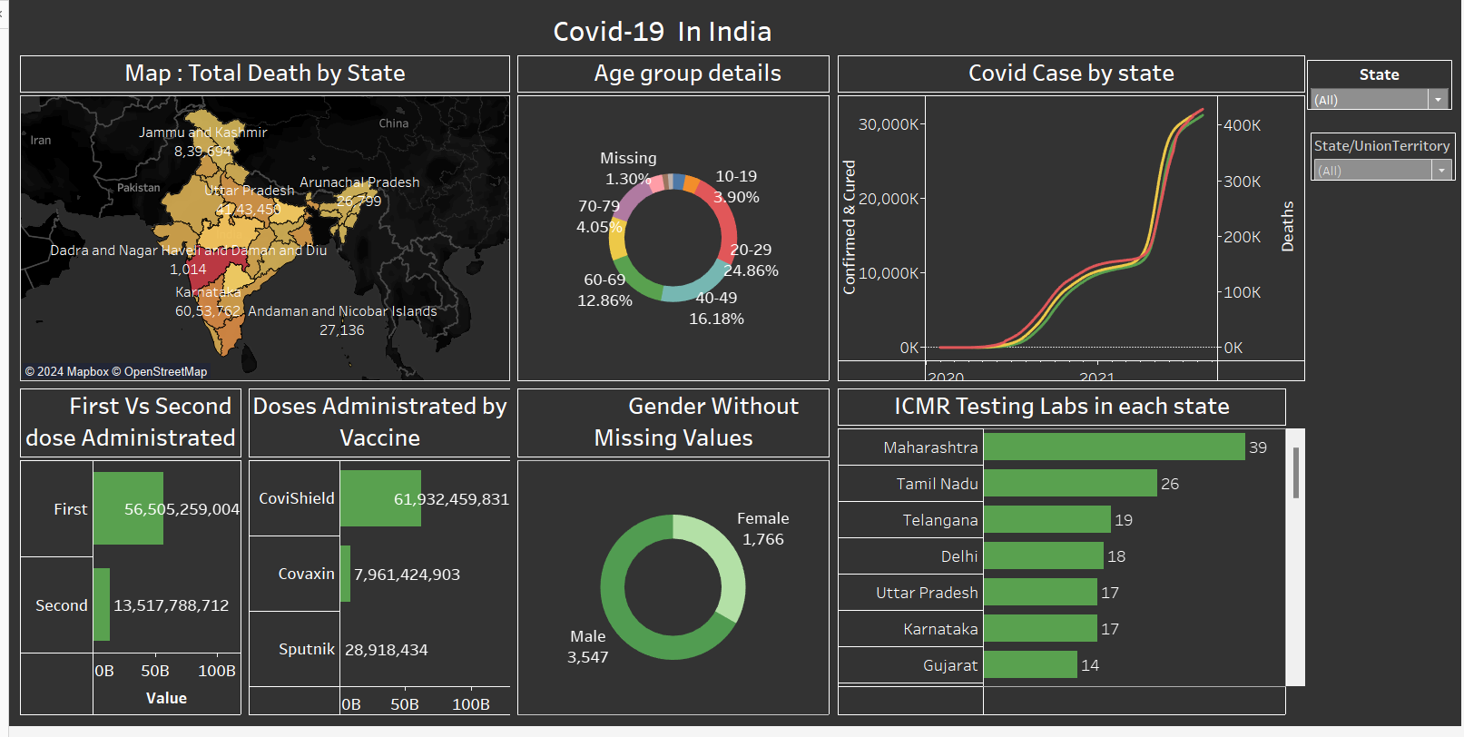

**6. Insights from the Charts and Dashboards**

* The map reveals that certain states, such as Maharashtra and Delhi, have experienced higher mortality rates compared to others.
* Elderly populations appear to be more susceptible to Covid-19, as indicated by higher case counts in older age groups.
* The line chart shows fluctuations in case numbers over time, with some states experiencing multiple waves of infections.
* Vaccination efforts have ramped up significantly, with a notable increase in the administration of second doses in recent months.
* The distribution of vaccine doses by type varies across states, reflecting the availability and distribution strategies adopted.
* Gender distribution of Covid-19 cases appears to be relatively balanced, with no significant disparities observed.
* Disparities in testing lab availability exist between states, with some regions having more robust testing infrastructure than others.

### 7. Conclusion

In conclusion, this analysis provides valuable insights into the Covid-19 situation in India. The findings highlight the need for targeted interventions to address regional disparities in mortality rates, vaccination coverage, and testing infrastructure. By leveraging data-driven insights, policymakers can make informed decisions to impact of the pandemic and safeguard public health.